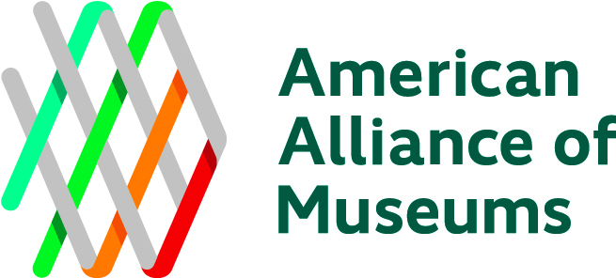

Automated Clearing House (ACH) Vendor/Payee Enrollment and Authorization

Individual Vendor/Company/Museum

AMERICAN ALLIANCE OF MUSEUMS
2451 Crystal Drive, Suite 1005
Arlington, VA 22202
Email: accounting@aam-us.org | P: 202-289-9129 F: 202-289-6578

PAYEE INFORMATION
Name (Required) | Vendor Number (AAM-Assigned)
Address (Required) | SSN or FEIN (Required for Vendors only)
Telephone Number (Required) | Email Address
Select One: Initial Enrollment Change of Account # Discontinue

FINANCIAL INSTITUTION INFORMATION
Bank Name (Required) | Bank Address
Account Number* (Required) | Routing/ABA Number* (Required)
*Please refer to sample check below to locate your bank account number and routing number:

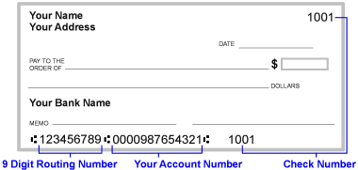

AUTHORIZATION
I authorize American Alliance of Museums and the financial institution listed above to deposit my payment automatically to my designated account each time a payment is made and, if necessary, to adjust or reverse a deposit for any entry made to my account in error by AAM. This authorization will remain in effect until I have cancelled it in writing and in such time as to afford AAM a reasonable opportunity to act upon it. I will notify AAM of any changes made to my bank account information.

Signature | Title:
 | Date:

