Sustainability Excellence Awards 2020
Application Form

Thank you for your interest in the AAM Environment and Climate Sustainability Excellence Awards. These awards were created to recognize innovative efforts towards improving environmental sustainability in museums and their communities. Please contact environmentandclimate@aam-us.org with any questions.
Museum Information
Museum Name |  | Museum Phone
Address 1 |  | Museum Website
Address 2 |  | Museum AAM Membership Type
City, State Zip |  | Museum AAM Membership #
Application Submitter Contact Information
Submitter Name |  | Title
Organization (if different than Museum) |  | Submitter Phone
Address 1 (if different than Museum) |  | Submitter Website (if different than Museum)
Address 2 (if different than Museum) |  | Submitter AAM Membership Type
City + State + Zip (if different than Museum) |  | Submitter AAM Membership #
Date Application Fee Mailed to AAM P.O. Box |  | Payer’s Name on Application Fee Check  (if different than Submitter)
Museum Size
☐ Small Museum
Less than $1 million annual operating budget OR less than 10,000 square feet in facilities.

☐ Large Museum
Greater than $1 million annual operating budget OR greater than 10,000 square feet in facilities.

Museum Type (type an “x” next to all that apply)

__ Aquarium
__ Anthropology
__ Arboretum/Botanic Garden
__ Art
__ Children’s
__ Culturally Specific
__ Hall of Fame
__ Historic House
__ Historic Site
__ History
__ Historical Society
__ Military/Battlefield
__ Nature Center
__ Natural History
__ Planetarium
__ Presidential Library
__ Science/Technology
__ Sculpture Garden
__ Transportation
__ Visitor Center
__ Zoo
__ Other _____________________

Submission Category
__ Facilities
A change to the facility through construction/renovation demonstrating an innovative approach to achieving significant sustainability goals. It may include facility, site, or operations leading to enhancement in one or more below areas: Indoor air, Waste, Materials, Transportation, Health, and Energy.
Recommended (Optional) for Facilities category
Energy Star Portfolio Manager (ESPM) Property ID # _____________________________,

__ Exhibitions
An exhibition design demonstrating an innovative approach to achieving significant sustainability goals. It may include materials selection, significant recycling, significant energy reduction, etc.

__ Programming
A standalone program, or a program supporting a new facility project or exhibition, which presents an innovative approach to engaging the public on topics of sustainability. These may include community-based initiatives to improve sustainability or specific programs directed within the museum for the larger public.

Sustainability Excellence Awards 2020
Application Instructions

Submission Requirements
Applications should include a narrative and any applicable photos, charts, graphs, and references. The narrative and all applicable images and supporting materials should be saved as a PDF document with a total no more than 10 pages.
The narrative should address the following topics:
1. Description
Describe in detail the project/program you are submitting for this award. Include pictures, designs, or examples of program materials if you wish. In your narrative, be sure to address the following questions:
- How and why did the project/program come about?
- What obstacles were overcome in implementing the project/program?
- How did environmental sustainability figure into project/program planning?
- If your project pursued a sustainability rating system (LEED, Living Building, Well, SEED, etc), what level did it achieve and what strategies were implemented?

2. Objectives
List the project/program's environmental sustainability objectives. Describe how they were established, if they changed during project/program development, and if they were achieved.
3. Outcomes
Describe the outcomes of the project/program. Describe how the project could serve as a good model for other projects/programs. Evaluate the significance of the project/program's impact on environmental sustainability. Include relevant metrics such as energy/water performance, materials use, and other data if relevant.
4. Team
List the people and firms involved in the project, and their roles.

Deadline & Fee
Submit your PDF and a completed 2-page application form (the first two pages of this document) by email to environmentandclimate@aam-us.org. Submissions must be received by March 13, 2020 at midnight Eastern Time.
The application fee is $50 for non-members and $35 for AAM members. To pay, mail a check payable to “American Alliance of Museums” to:
American Alliance of Museums
P.O. Box 741970
Atlanta, GA 30374-1970
Be sure to write “2020 Sustainability Excellence Award” in the memo line of your check.

Late submissions will not be considered.

Selection Criteria
Winners will be selected by a panel of experts, according to the following criteria:
1. Has the project/program set ambitious but realistic goals in relation to available resources? | 20%
2. Have the project/program's goals and outcomes been clearly documented? | 20%
3. Will the project/program serve as a good example for other institutions? | 20%
4. Has the project/program had a significant impact on environmental sustainability? | 40%
e.g. Were the savings in energy, materials, water, etc. worthy of the
efforts (and cost) expended?
Has the project improved the natural environment and taken action to lessen the impacts of climate change?
Has the project changed visitor or staff behavior for the better?
Winners will be notified the last week of March. Winning teams will be asked to prepare and present images and slides of their submission at the Environment and Climate Network’s Sustainability Excellence Awards luncheon during the 2020 Annual Meeting in San Francisco.
AAM supports the use of Energy Star Portfolio Manager (ESPM). Nearly 30 municipalities around the country have a mandate for buildings of a certain size to benchmark through ESPM on an annual basis. The Environment and Climate committee strongly recommends museums to include their energy performance from ESPM (EUI). Visit the ESPM website, and see Appendix 1 for details.

Submission Checklist
To ensure your application is complete and submitted, please check the following:
☐ Pay application fee by sending a check to: P.O. Box 741970 Atlanta, GA 30374-1970
Checks should be made payable to The American Alliance of Museums and have “2020 Sustainability Excellence Awards” in the memo line.

☐ Complete and email application form (the first two pages of this document) and optional Energy Star Portfolio Manager # and screenshots (Appendix) to environmentandclimate@aam-us.org

☐ Complete and email 10-page narrative PDF (including images) to environmentandclimate@aam-us.org

Appendix 1

Note:
- Confirm energy data is available on a regular basis. Ensure data input is complete with fuel types (i.e. gas, electric, steam, fuel oil) on Energy Star Portfolio Manager (ESPM).
- Go to “Summary” tab on ESPM, take a screen shot of the EUI table and submit. (See Sample screen shot 1 below)
- Go to “Energy” Tab, take a screen shot of the utility graph and submit. (See Sample screen shot 2 below).

ESPM submission is confidential and will not be any part of publications. If you have questions about using ESPM, submit them to the Help desk on ESPM. If you have other questions about ESPM, please email Angela Moore amoore@mohistory.org

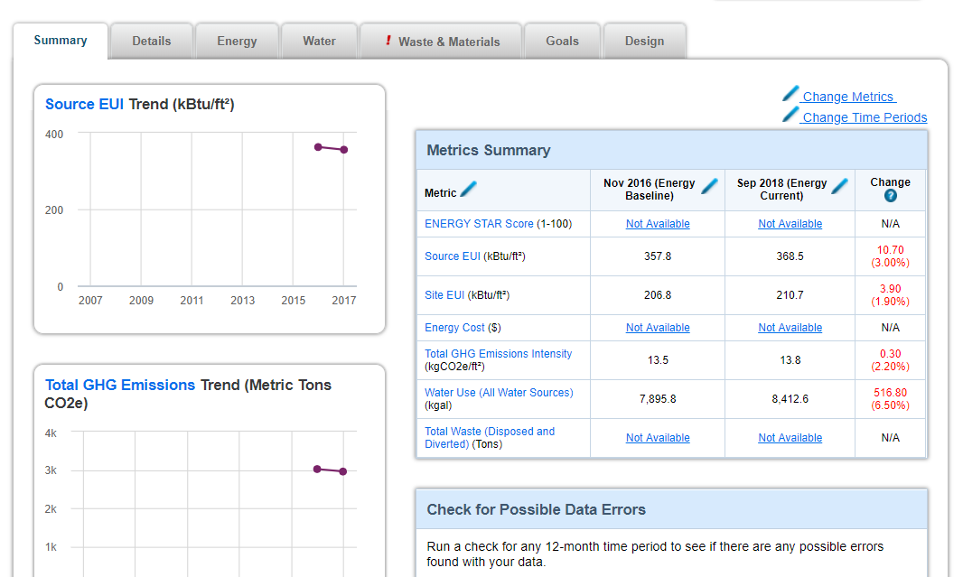

Sample screen shot 1: Submit Summary EUI

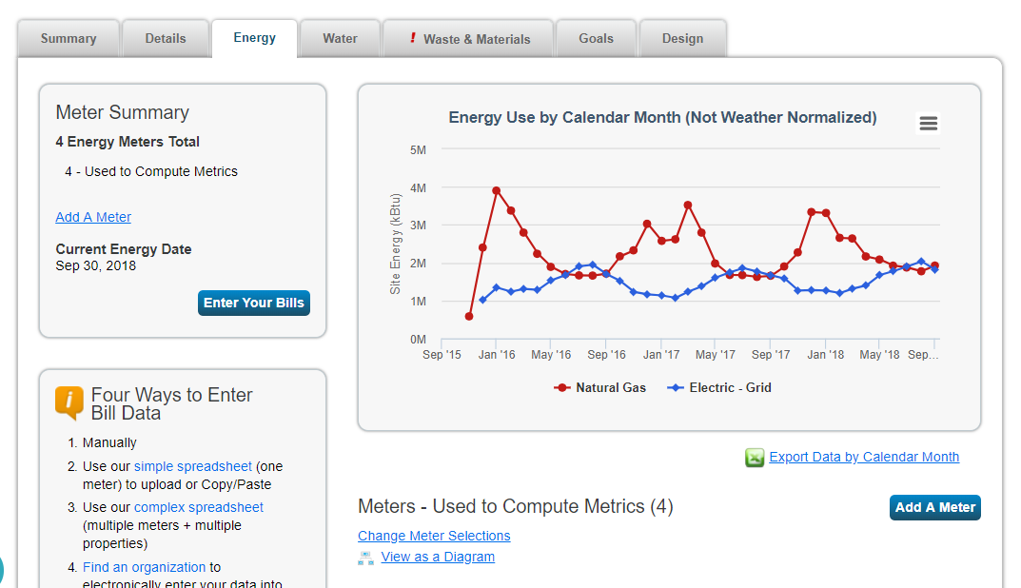

Sample screen shot 2: Submit Energy Chart

