The below sample marketing and communications report is created as a template for museum marketers to build from based on their departmental and organizational goals, and track changes over time. It is by no means prescriptive. Based on your museum’s use of various platforms, reporting systems, and capacity, the outcome of this template report will vary greatly from institution to institution. We offer this as a tool to start from.
Sample Marketing & Communications Report
[Timeframe (quarter, month, season, year, etc.) the Report Covers]

TL; DR
Here, describe high level goals for the timeframe, analysis of the detailed metrics outlined throughout the report, and take-aways useful for your staff and leadership to be aware of.

[Timeframe] Goals
Here, describe the goals set for your timeframe including any specific marketing campaigns launched or concluded. List whether you accomplished those goals, why or why not, and what you have learned during this timeframe.

[Upcoming timeframe] Goals
Here, describe the goals you will set out to accomplish in your upcoming timeframe including any specific marketing campaigns you plan to launch or conclude. List what will be indicators of success.

Email Analytics
In this section, provide the average open and click rates for email campaigns and newsletters. Specific notes and anything noteworthy is can be included in the analysis section below the chart.
Email Type (name of newsletter or campaign) | Open Rate | Click Rate | Notes on effectiveness (increase in revenue, traffic to website, etc.)

Write out a brief analysis of the email marketing metrics.

Social Media Analytics
You may use some, all, or none of these social media platforms for your museum. The following platform templates can be adapted to different social media platforms as needed.
Twitter
[Timeframe] Top Posts - Twitter
Insert a screenshot of the post here
Post Reach:
Post Likes:
Post Shares:

Post Reach:
Post Likes:
Post Shares:
Post Reach:
Post Likes:
Post Shares:

Insert a screenshot of the post here

Insert a screenshot of the post here

Metric | Total Number for [timeframe] | Percent Change over  [last timeframe]
Tweets | 845 | 8%
Twitter Impressions | 845 | 8%
Profile Visits | 845 | 8%
Mentions | 845 | 8%
Followers | 845 | 8%

Twitter Audience – if applicable, match to your museum’s personas/audience types
Include here any notes if audience has notably shifted since the last timeframe as well as a screenshot of Twitter’s audience analytics page (example below).

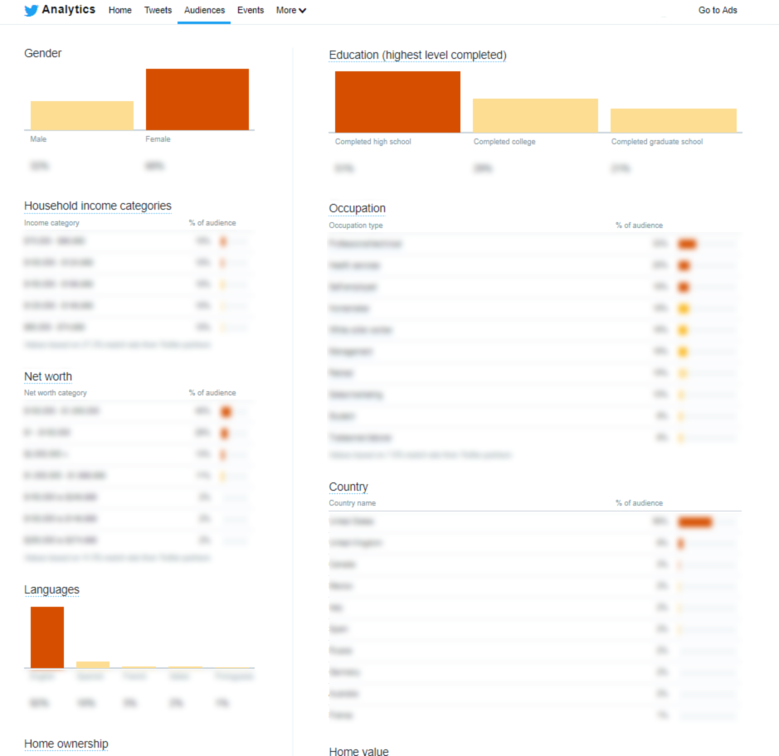

Facebook
[Timeframe] Top Posts
Post Reach: 85 | Post Likes: 123 | Post Shares: 56
Post Reach: 85 | Post Likes: 123 | Post Shares: 56
Insert a screenshot of the post here
Insert a screenshot of the post here

Metric | Total Number for [timeframe] | Percent Change over  [last timeframe]
Posts | 845 | 8%
Post Reach | 845 | 8%
Post Engagements | 845 | 8%
Page Likes | 845 | 8%
Page Followers | 845 | 8%

Post Reach: 85 | Post Likes: 123 | Post Shares: 56

Insert a screenshot of the post here

Facebook Audience – if applicable, match to your museum’s personas/audience types
Include here any notes if audience has notably shifted since the last timeframe as well as a screenshot of Twitter’s audience analytics page (example below).
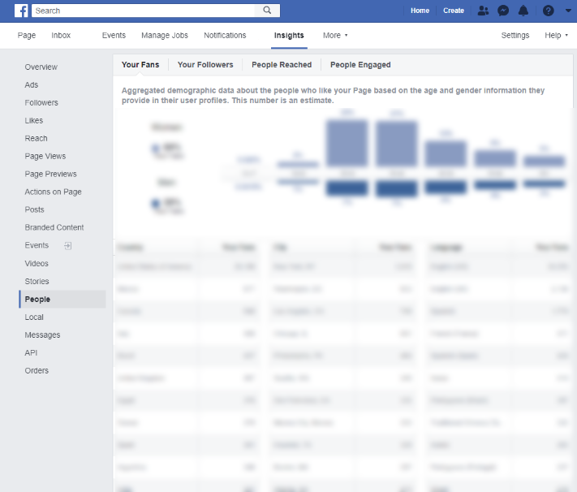

LinkedIn
[Timeframe] Top Posts
Metric | Total Number for [timeframe] | Percent Change over  [last timeframe]
Posts | 845 | 8%
Post Reach | 845 | 8%
Post Engagements | 845 | 8%
Page Likes | 845 | 8%
Page Followers | 845 | 8%
Post Reach: 85 | Post Likes: 123 | Post Shares: 56
Insert a screenshot of the post here
Insert a screenshot of the post here
Insert a screenshot of the post here
Post Reach: 85 | Post Likes: 123 | Post Shares: 56
Post Reach: 85 | Post Likes: 123 | Post Shares: 56

Instagram
Q3 Top Posts
Post Reach:
Post Likes:
Post Shares:
Insert a screenshot of the post here
Insert a screenshot of the post here
Post Reach:
Post Likes:
Post Shares:

Insert a screenshot of the post here
Post Reach:
Post Likes:
Post Shares:

Metric | Total Number for [timeframe] | Percent Change over  [last timeframe]
Tweets | 845 | 8%
Twitter Impressions | 845 | 8%
Profile Visits | 845 | 8%
Mentions | 845 | 8%
Followers | 845 | 8%

Social Media Ad Campaigns
If your museum places social media ad campaigns, place screenshots here as well as analysis of how the campaigns performed based on your goals.
Placeholder
Placeholder

Google Analytics

Metric | Users | Sessions | Sessions  per user | Average session duration | Bounce rate
[timeframe] total | 200,000 | 400,000 | 2 | 2:00 | 30%
Percent change from [previous timeframe] | 8% | 8% | -8% | -8% | 8%

Top 20 web pages
This is an example and should be modified based on your museum’s goals. You can list out the webpages with the largest number of views, longest session durations, most unique users, etc. Additionally, if your museum tracks search terms, listing those here can provide further insight into your web user’s interests.
- Placeholder
- Placeholder
- Placeholder
- Placeholder
- Placeholder
- Placeholder
- Placeholder
- Placeholder
- Placeholder
- Placeholder
- Placeholder
- Placeholder
- Placeholder
- Placeholder
- Placeholder
- Placeholder
- Placeholder
- Placeholder
- Placeholder
- Placeholder

Acquisition and Conversion
Include screenshots of acquisition data based on your museum’s goals such as top channels and campaigns. Include an analysis of conversion rates if your museum tracks this for newsletter sign ups, ticket purchases, etc.

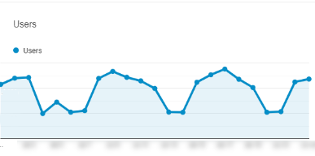
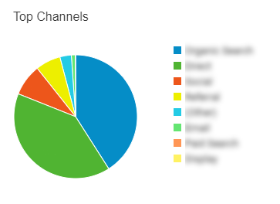
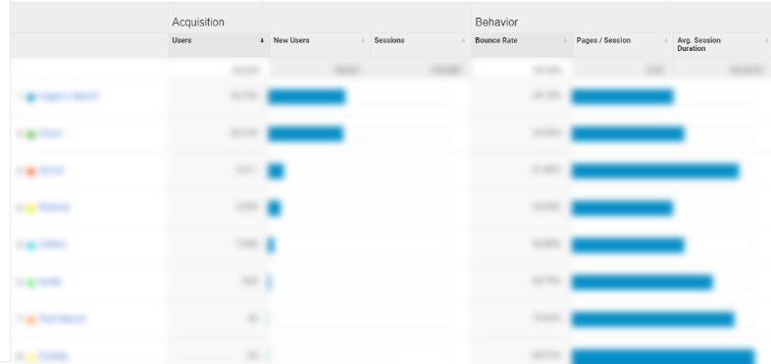

Website audience – if applicable, match to your museum’s personas/audience types
Include screenshots of audience data based on your museum’s goals such as age, location, language, and interests.
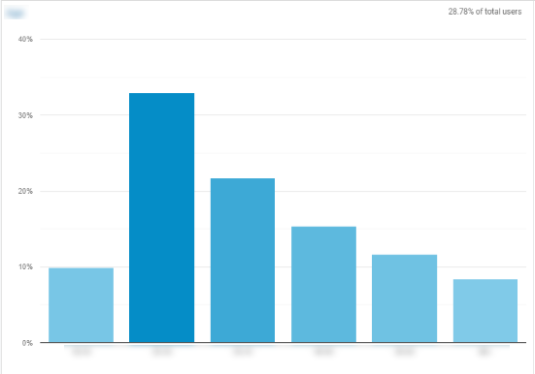
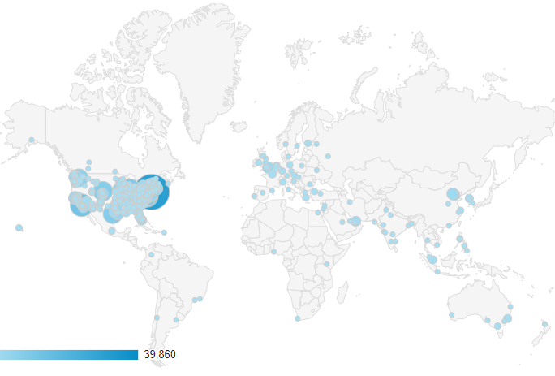

Website analysis
Include an analysis of website metrics here. Be sure to highlight any changes in user demographics, acquisition, or behavior. Describe the reason for any major spikes or drops in website use.

Google Ad Campaigns
If your museum places Google ads, place screenshots here as well as analysis of how the campaigns performed based on your goals.
Placeholder
Placeholder

[Timeframe] Press Mentions
Total press mentions: x

Title of article hyperlinked – short description, media outlet name
Title of article hyperlinked – short description, media outlet name
Title of article hyperlinked – short description, media outlet name
Title of article hyperlinked – short description, media outlet name
Title of article hyperlinked – short description, media outlet name

